**Name:** Keegan Vaz

**SEC:** TE CMPN-B

**Roll No.:** 28

**PID:** 192120

**Experiment 8**

**AIM:**  Study and Installation of Network Simulator (NS3)

**Theory:**

The ns-3 simulator is a discrete-event network simulator targeted primarily for research and educational use. The [**ns-3 project**](http://www.nsnam.org/), started in 2006, is an open-source project developing ns-3.

The purpose of this tutorial is to introduce new ns-3 users to the system in a structured way. It is sometimes difficult for new users to glean essential information from detailed manuals and to convert this information into working simulations. In this tutorial, we will build several example simulations, introducing and explaining key concepts and features as we go.

As the tutorial unfolds, we will introduce the full ns-3 documentation and provide pointers to source code for those interested in delving deeper into the workings of the system.

A few key points are worth noting at the onset:

* ns-3 is open-source, and the project strives to maintain an open environment for researchers to contribute and share their software.
* ns-3 is not a backwards-compatible extension of [**ns-2**](http://www.isi.edu/nsnam/ns); it is a new simulator. The two simulators are both written in C++ but ns-3 is a new simulator that does not support the ns-2 APIs.

Network Simulator 3 -

NS-3 is free software, licensed under the GNU GPLv2 license, and is publicly available for research, development, and use. NS-3 has been developed to provide an open, extensible network simulation platform, for networking research and education. In brief, NS-3 provides models of how packet data networks work and perform, and provides a simulation engine for users to conduct simulation experiments.

NS3 GUI For ns3 we don't have any GUI. In order to obtain a graphical interface for ns3 we will write simulation scripts in C++ or python. NS-3 does not contain a default graphical animation tool, we currently have two ways to provide animation, namely using the PyViz method or the NetAnim method.

Benefits : The network simulation tools are a modern technology. The simulator helps the user to develop the networks with real time. It is useful to test new networking protocols or changes in the existing protocols.

Purpose: Network simulation offers an efficient, cost-effective way to assess how the network will behave under different operating conditions. Simulation results can be analyzed to assess network performance, identify potential problems, understand the root cause, and resolve the issues prior to deployment.

**For the installation of NS3, VMware workstation is required to be installed, along with an Ubuntu system.**

1. Download VMWare workstation from the website: [https://my.vmware.com/en/web/vmware/downloads/info/slug/desktop_end_user_compu ting/vmware_workstation_player/15_0](https://my.vmware.com/en/web/vmware/downloads/info/slug/desktop_end_user_compu%20ting/vmware_workstation_player/15_0)

2. Download Ubuntu 20.04.01 Desktop AMD 64 from the website: <https://ubuntu.com/download/desktop>

3. Install VMWare workstation onto the computer system and open it

4. Set up the VMware workstation: a. Create a new virtual machine by selecting “Create New Virtual Machine.”

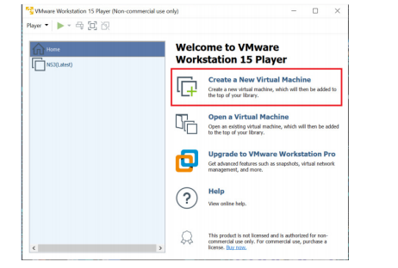

1. In the installer wizard, select installer disc image file(iso) and select the downloaded Ubuntu 20.04.01 AMD 64 iso file by browsing through the computer download files.

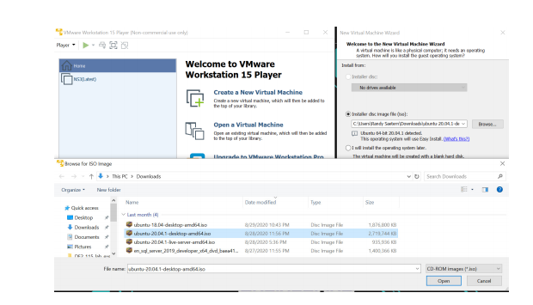

c. Name the machine and set the password.

d. Configure the Hardware:

i. For memory: set the value to 4600 MB or above.

ii. For faster VMware, set processors to 2.

5. Power on the virtual machine and let the machine update.

6. Within the Virtual machine, download NS3 on the VM by opening Mozilla firefox and downloading from the NS3 website.

7. Install prereq packages on Ubuntu using terminal:

a. Open the terminal by right clicking the desktop and select “open in terminal.”

b. Paste in this code and then press enter: sudo apt-get install g++ python3 python3-dev pkg-config sqlite3 python3- setuptools git qt5-default mercurial gir1.2-goocanvas-2.0 python-gi python-gi-cairo python3-gi python3-gi-cairo python3-pygraphviz gir1.2- gtk-3.0 ipython3 openmpi-bin openmpi-common openmpi-doc libopenmpi-dev autoconf cvs bzr unrar gdb valgrind uncrustify doxygen graphviz imagemagick texlive texlive-extra-utils texlive-latex-extra texlivefont-utils dvipng latexmk python3-sphinx dia gsl-bin libgsl-dev libgsl23 libgslcblas0 tcpdump sqlite sqlite3 libsqlite3-dev libxml2 libxml2-dev cmake libc6-dev libc6-dev-i386 libclang-6.0-dev llvm-6.0-dev automake python3-pip libgtk-3-dev synaptic vtun lxc uml-utilities

c. After the packages have finished downloading, paste in this code and press enter: sudo pip3 install cxxfilt

8. After installing the required packages, create a folder named workspace in the home directory and then put the NS3 tar package into the workspace. See example figure below.

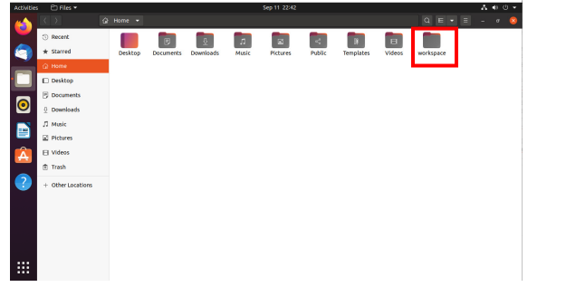

1. Go to terminal and input these commands consecutively after each command finishes executing:

cd

cd workspace

tar xjf <Name of Ns3 downloaded file name>

cd <Name of extracted Ns3>

./build.py --enable-examples --enable-tests

1. Test the NS3 build and installation success by running test.py in the ns directory using the following commands: cd ns- ./test.py

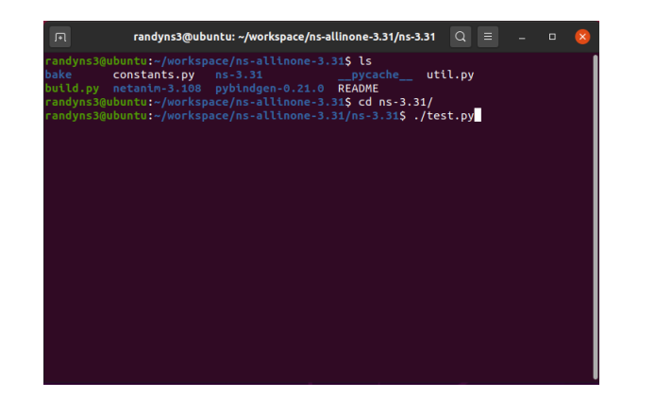

1. If all of the tests were passed, Congratulations! NS3 has now been installed successfully.

Output SS:

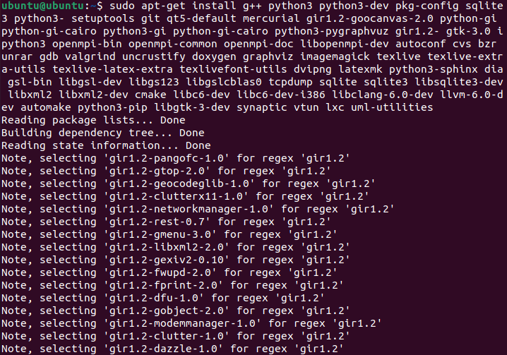

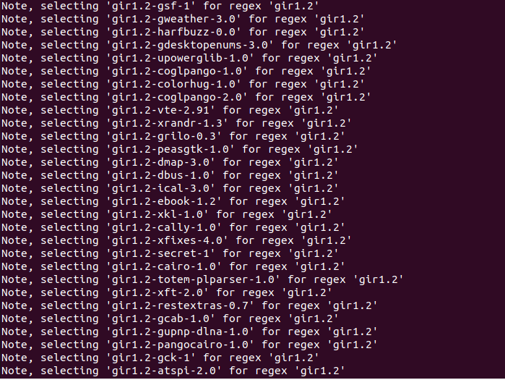

**CONCLUSION:** Thus, we have studied and successfully install NS3.